**Date:** 18.04.2019

**Attendees:** Mesut Uğur, Furkan Karakaya

**Location:** Electrical Machines Laboratory

**Target:** V1.3 Gate Driver Board (#1)

**Test type:** Inverter test with RL load

**Aims before the test:**

**1.** To test the V1.3 GDB as an inverter

**2.** To verify that the inverter is working at 300Vdc voltage

**3.** To verify that the inverter is working at 8Arms current

**4.** To verify that the inverter can deliver 2kW power to the load (Thermal test)

**5.** To verify that the inverter is working at nominal values with 40kHz switching frequency

**Conditions:** 22 Ohm Ron, 2 Ohm Roff. 0-300V VDC. RL Load: Five different stages. 10kHz-40kHz fsw. 0.9 power factor. Sinusoidal PWM with 0.9 modulation index.

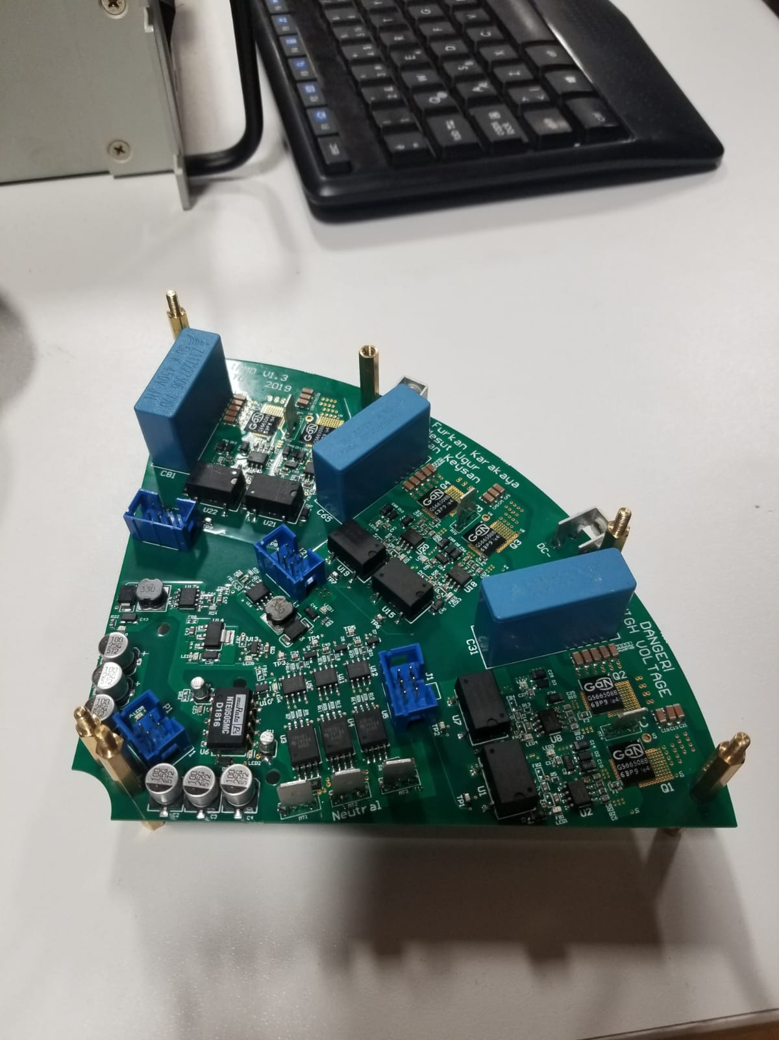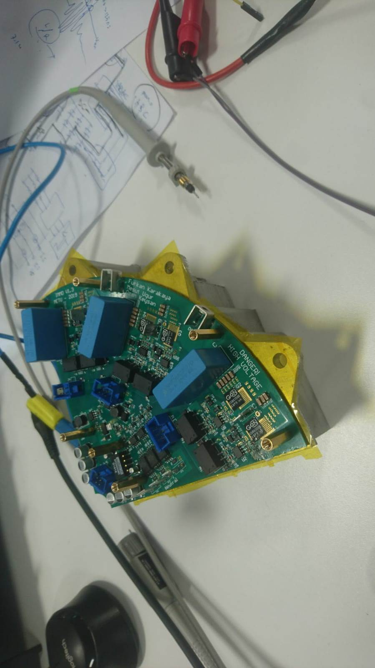

**Steps:**

**1.** The test steps and conditions are as below. In all steps, the DC link voltage is increased gradually.

1. Load stage-1 (Light load). 0-300V DC. 10kHz fsw. 400W output power.
2. Load stage-2. 0-300V DC. 10kHz fsw. 800W output power.
3. Load stage-3 (Medium load). 0-300V DC. 10kHz fsw. 1200W output power.
4. Load stage-4. 0-300V DC. 10kHz fsw. 1600W output power.
5. Load stage-5 (Full load). 0-300V DC. 10kHz fsw. 2000W output power.
6. Load stage-5 (Full load). 0-300V DC. 40kHz fsw. 2000W output power.

**2.** All the steps are covered and the inverter is working successfully at 300V DC bus voltage, 8A line current, 2kW output power and 40kHz switching frequency.

**3.** The thermal performance of the system is better than expected. The highest temperature which has occured around phase-B GaNs is 55 0C at full load.

**What to do next:**

**1.** Efficiency could not be measured. A test setup will be proposed to measure it.

**2.** The thermal model will be revisited with new power loss inputs (4-5W). The previous simulation showed 90 0C temperature around GaN case with 10W loss. Actual losses are predicted as 4-5W.

**3.** DC bus capacitor voltage ripple will be observed and compared with calculations and simulations.

**Results:**

**Caps or it didn’t happen !**

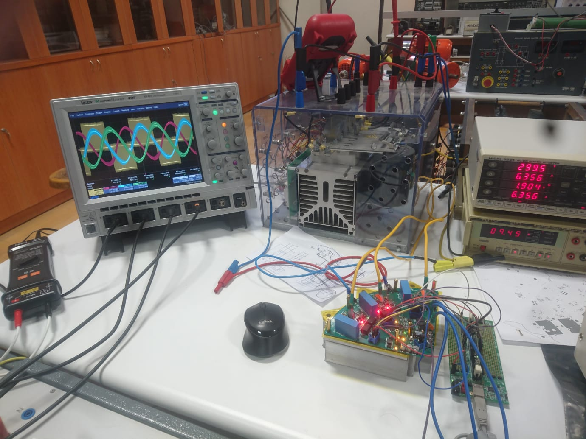

**1. Load stage-1, 10kHz:**





**2. Load stage-2, 10kHz:**





**3. Load stage-3, 10kHz:**





**4. Load stage-4, 10kHz:**





**5. Load stage-5, 10kHz:**





**6. Load stage-5, 40kHz:**





**7. Thermal results:**